1. Click the **Start Start menu** and select PC **Settings**.
2. Click **Update and recovery**.
3. Click on **Recovery**.
4. Remember next steps (step 5 to 10), becuse you should restart the PC!
5. Click **Restart now** under **Advanced Startup**.

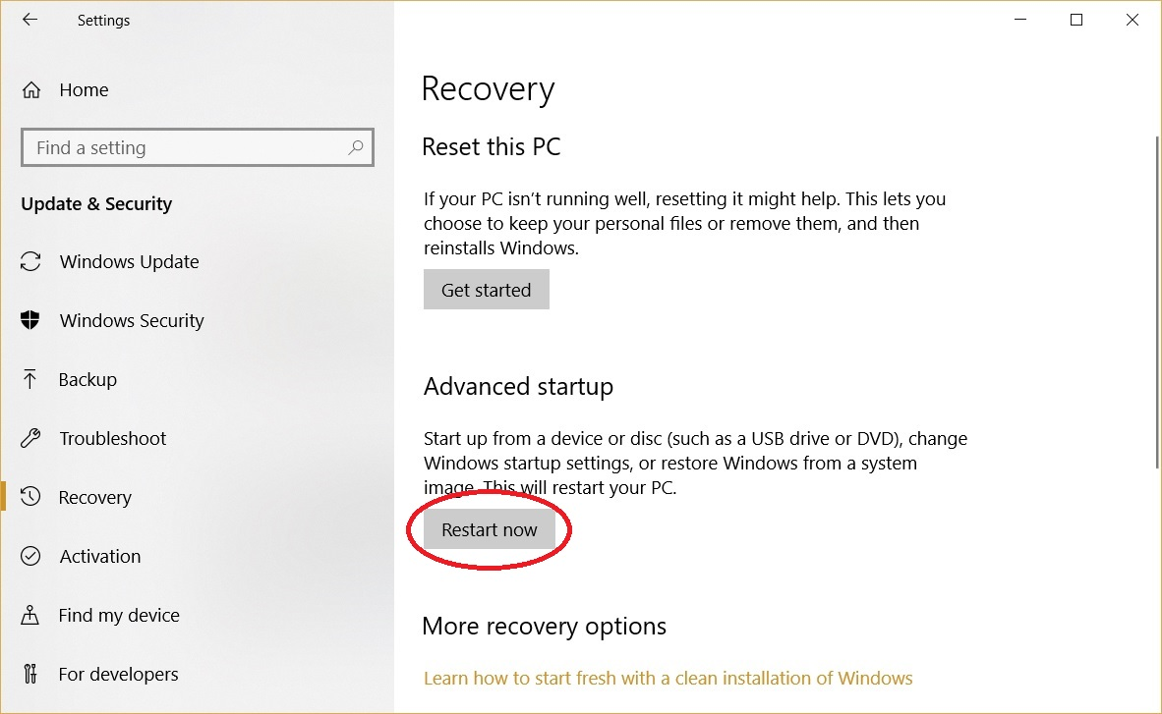

1. Click **Troubleshoot**.
2. Click **Advanced options**.
3. Click **Startup Settings**.
4. Click on **Restart**.
5. On the Startup Settings screen **press 7 or F7** to disable driver signature enforcement.

--------------------------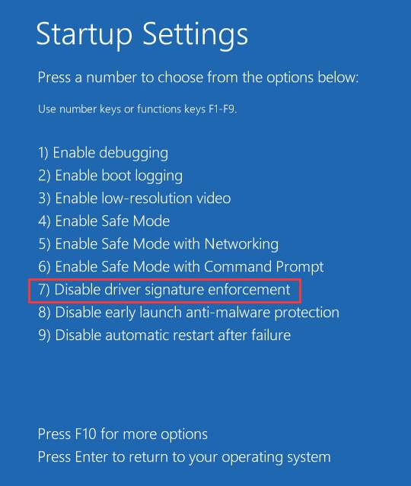

1. Now intstal Driver from **Device manager**.